

**Walking the Tightrope: Prospects for the UK Economy**

Speech given by

Charles Bean, Executive Director and Chief Economist of the Bank of England

Ismaili Centre, London 17 April 2008

1

All speeches are available online at [www.bankofengland.co.uk/publications/Pages/speeches/default.aspx](http://www.bankofengland.co.uk/publications/Pages/speeches/default.aspx)

Good evening! For much of the past fifteen years, we have had a pretty comfortable voyage in the good ship UK economy, with 62 consecutive quarters of generally robust expansion, coupled with low and stable inflation. But over the past year or so, the seas have got distinctly rougher, with the ongoing dislocation in financial markets threatening to generate a sharp slowdown at the same time as higher energy and food prices driven by global developments are pushing inflation up. Indeed, to judge by some of the recent newspaper coverage, our ship is already holed beneath the waterline and sinking fast. So tonight, I want to discuss the outlook for the British economy over the coming year or two, and the strategy that the Bank’s Monetary Policy Committee is pursuing to navigate across these more treacherous waters.

Let me start with the dislocation in credit markets, which began in earnest last August and which is proving more pervasive and longer-lasting than was initially expected. While the turmoil had its epicentre in the United States sub-prime housing market, it is best seen as the abrupt ending of a more general boom in credit expansion, to which a number of factors contributed. First, an abundance of savings, particularly from Asia, coupled with temporarily loose monetary policies to sustain growth in the wake of the dot-com bust and the 9/11 attacks, meant the availability of an ample supply of funds at a low rate of interest. That combination in turn encouraged hedge funds and similar institutions to leverage up speculative positions in order to generate satisfactory rates of return for their investors; the result was a widespread underpricing of risk across a swathe of assets. Second, regulatory requirements on banks’ capital encouraged them to sell on packages of mortgages and other loans to end investors, thus shifting them off balance sheet (or at least so it was thought). Third, originators of loans, expecting to sell them on, ceased to have the same incentive to be careful who they lent to, as they no longer bore the risk; in the latter stages of the sub-prime lending boom this resulted in some pretty dubious lending practices. Fourth, investors placed too much weight on the ratings of the quality of such securities, treating them as gospel rather than a guide. Fifth, in making those ratings, the agencies erroneously extrapolated from past behaviour and underestimated the likelihood of defaults in the event of house prices falling.

As defaults on recent vintages of loans to sub-prime US households rose through last year, so investors became increasingly aware of the shaky foundations on which valuations of securities backed by sub-prime mortgages were based. In August, that resulted in virtual closure of these markets. Importantly, it was not just securities backed by sub-prime assets that suffered, but all asset-backed securities became suspect, including those backed by loans to prime UK households,

who historically have had very low default rates, even during the worst of the house-price correction of the early 90s. Furthermore, many of the securitised loans turned out not really to have been shifted off balance sheet, as the vehicles into which they had been transferred often had contingent funding lines to the originating bank, which were triggered by these funding difficulties. So the banks found themselves with loans that they had expected to securitise, or thought they had already shifted off balance sheet, with no obvious buyers.

In turn, these funding pressures resulted in a hiatus in the money markets, as banks hoarded surplus funds in case they required them later, rather than lend them on to other banks as they would have in the past. And over time that has been reinforced by growing concerns as to some potential counterparties’ ability to repay. As a result, the interest rates on three-month loans between banks, which normally stay pretty close to actual or expected policy rates, have exceeded them by a margin which has varied between 50 and more than 100 bps (Chart 1).

During the recent turmoil, all central banks have expanded their normal operations, by extending the maturity of their lending and, in some cases, expanding the range of collateral accepted. In our case, there have been three changes since the start of the turmoil. We have increased the total quantity of reserves supplied by nearly a half. We have increased the proportion of total funds supplied through open market operations that is for three months or longer to three quarters. And we have widened the range of collateral accepted in our three-month operations to include mortgage-backed securities and some other highly-rated assets. The Bank is continuing to work with the relevant parties to develop approaches that will help to ease the strains and act as a bridge to a more normal outcome.

At root, the problem is one of a lack of trust in a context of incomplete information about the scale and distribution of the likely losses associated with mortgages, other loans and derivative products. As the experience of Japan during its ‘lost decade’ attests, a return to normality in the banking sector requires both credible revelation of those losses, as well as injections of fresh capital. We are well down the revelation path, at least in regard to losses associated with the US sub-prime mortgage securities market. The IMF has estimated these at around $450 billion, evaluated at current market values (alternative assumptions can generate slightly different figures), although reasonable projections of default rates suggest that the actual losses if the assets are held to maturity will be considerably smaller. Roughly half of those losses are thought to reside within the

international banking system, of which around two-thirds has been declared. Even so, the adjustment is likely to take a considerable time yet and there is the threat of further impairment to banks’ balance sheets as growth in the advanced economies slows.

How does all this affect the outlook for the UK economy? The difficulties in funding have naturally led banks to cut back on the quantity of new loans they extend, while the higher marginal cost of funds has led them also to increase the rates that they charge customers. The Bank carries out a regular quarterly survey of lenders, and the two most recent surveys, carried out before Christmas and last month, pointed to less favourable terms on, and reduced availability of, credit to households (Chart 2) and businesses (Chart 3).

The key question for the MPC is how this will impact on spending on goods and services. Although there has been an expansion in unsecured lending – credit cards and the like – in recent years, the bulk of lending to households – about 90% – has been secured on property. The bulk of the tightening in the terms and availability of credit to households will therefore fall on mortgage lending, and we are already seeing this as lenders withdraw products, particularly for riskier borrowers (Chart 4), and expect borrowers to inject more of their own savings in order to receive a low interest rate. It is important to recognise that some of these changes will persist beyond the resolution of the current hiatus in credit markets. While the securitisation of mortgages will probably survive in some form, the greater awareness of the risks associated with securitised lending will mean that the cost of funds will be higher, relative to policy rates. And it is also likely that increased caution on the part of lenders will persist. In many ways, this is just a (partial) return to the situation that obtained before the great securitisation boom.

The easy availability of credit for house purchase in recent years has almost certainly been one of the factors that have contributed to the 80% rise in the ratio of house prices to earnings over the past decade, though factors such as demographic developments, the transition to a world of low inflation and low interest rates, and constraints on supply have also played a role. Housing market activity has already slowed over the past year, with mortgage approvals for house purchase around 40% down on a year ago and indicators from the Home Builders Federation and Royal Institute of Chartered Surveyors looking very subdued. And house prices fell 1½% in the first quarter, according to the average of the Nationwide and Halifax house price indices. The reduction in the availability of mortgage funds seems likely to keep activity subdued and put further downward

pressure on house prices relative to earnings, though it is difficult to say just how far adjustment will go and how fast it will be.

But the MPC targets CPI inflation, not house prices. It is therefore the impact on demand – and thus on inflationary pressure – that matters to us. Some commentators look at the historically strong correlation between house price inflation and consumption growth (Chart 5) and conclude that if house prices fell significantly, then that would also generate a sharp slowing in consumer spending. But it is not clear that this need be so. Lower house prices do not make us collectively worse off.

They merely redistribute wealth from home owners who expect to trade down to those not yet on the housing ladder or who are still moving up it. So any decline in the value of the housing stock should not have much net effect on spending through the so-called ‘wealth effect’.

Housing wealth can, though, affect spending because it represents collateral against which households can borrow. However, according to an annual survey carried out by the Bank, only 5% of mortgagors have less than 20% equity in their home. So house prices would have to fall a long way before a lack of collateral became a constraint for most homeowners. Far more relevant at the present juncture is the general lack of funds for the lenders to advance against that collateral.

In my view, the historical correlation mainly reflects the fact that, for most of the period, house prices and consumption were both driven by the same underlying forces, particularly swings in expectations about future incomes. And notice that the correlation has largely disappeared since the start of this decade, at just the time that house prices are likely to have been driven by other factors. So I am reasonably sanguine about the implications of any fall in house prices for consumer spending.

However, household spending growth *is* likely to be subdued for other reasons. According to the official data, retail spending growth held up surprisingly well in January and February (Chart 6), though Tuesday’s numbers from the British Retail Consortium suggest that spending was weak in March. But two factors in particular will bear down on spending in the coming months. First, higher consumer price inflation and slower employment growth will weigh on real income growth.

Second, the reduced availability of credit will inhibit spending. So the climate in the High Street is likely to be pretty chilly, especially in comparison with the heady growth of recent years. But as I shall explain later, *some* reduction in the growth of consumer spending, and domestic demand more

generally, is in any case necessary; the question is whether we have too much, too little, or just the right amount.

The credit crunch will also potentially affect capital expenditures. According to the Bank’s regional Agents, only a minority of businesses have so far encountered difficulties in obtaining finance. But that may just reflect the fact that many businesses have existing credit lines upon which they can draw and constraints only start biting when new facilities are established. So it may just be a matter of time. And there are signs that the heightened uncertainty about the outlook is leading to greater caution in framing investment plans (Chart 7). So some slowdown in business investment growth would also appear to be in prospect, while residential investment is bound to be impacted by the slowdown in the housing market.

With output growth slowing in the UK’s main export markets – particularly the United States – the outlook might sound rather bleak. However, another major development since the beginning of August 2007 has been a 12% fall in the effective exchange rate for sterling (Chart 8) – the value of sterling compared with a basket of currencies, weighted by their relative importance in our international trade. That will provide a fillip to net exports, though it will tend to push up import costs too. Broadly speaking, the fall is of the same order as the depreciation after our exit from the Exchange Rate Mechanism back in September 1992. Economists sometimes used to use a rule of thumb that a one percentage point fall in sterling had the same effect on output as a ¼ percentage point cut in interest rates. Now the impact of a change in the exchange rate will depend on what caused it and whether it is expected to persist but, at least according to this crude yardstick, the stimulus from the fall in sterling would be roughly equivalent to a cut in interest rates of three percentage points. That should go some way to offsetting the contractionary impact of the dislocation in credit markets, as well as generating a more sustainable composition of demand and a much-needed reduction in the UK’s current account deficit.

The credit crunch is, however, not the only shock the MPC has to deal with. For much of the past decade or so, the advanced economies have experienced a beneficial tailwind as the integration of China, India and the Eastern European economies into the international trading system allowed production to move overseas to take advantage of markedly lower labour costs. This has been facilitated by advances in information technology which allow the production process to be decomposed, for instance with specifications developed and refined in this country, then speedily

transmitted overseas for production in China, etc. These technological developments have also enhanced the international tradability of services, for example allowing call centres (at the less skilled end) and programming (at the more skilled end) to be located overseas.

This exploitation of comparative advantage has conferred a terms of trade gain on the advanced economies, raising the price of our exports relative to our imports. But it has not been without some costs, as the demand for relatively unskilled labour has declined, thus tending to increase the degree of wage inequality. And for businesses going through the outsourcing and offshoring process it has involved painful adjustment costs. Nevertheless, by raising the real purchasing power of a given wage, it has allowed real living standards to rise faster than would otherwise be the case, and at least temporarily reduced the degree of inflationary pressure experienced for a given degree of spare capacity in the economy.

For the United Kingdom, this has not been the only consequence of globalisation. Substantial inflows of migrant workers from Eastern Europe, especially Poland, have boosted the labour supply and with it potential and actual output. The recent House of Lords report on the impact of migration correctly noted that it is the impact of migration on output per head, rather than on total output, that really matters. But an important feature that received less attention was the endogeneity of these flows to the state of the UK labour market, with UK businesses increasingly sourcing labour from these economies when they could not find domestic workers with the necessary skills, as well as the impact of these flows in increasing the degree of competition in the labour market. Again this has allowed the MPC to run the economy at a higher level of activity than would otherwise have been the case.

But this beneficial tailwind from globalisation has gradually turned into a headwind. The biggest gains from the integration of the emerging market economies into the global trading system probably came early on as the most obvious opportunities to outsource and offshore were seized. Moreover, one would expect that as these economies develop, so their real labour costs will gradually catch up with those in the advanced economies, eliminating the original gains from trade. With a large fraction of the Chinese population still in the rural sector, one might expect that it will be a while before this happens. But there is a limit to how quickly the labour can be transferred from rural areas into the cities and absorbed into the industrial sector. As a result there are already signs that Chinese labour costs are starting to rise.

Of even more significance recently has been the upward pressure on commodity prices as these economies develop. Much of the increment to the demand for oil over the past four years is attributable to the emerging market economies. Rapidly rising demand for oil has been confronted by relatively inelastic supply, resulting in inexorably rising oil prices (Chart 9). Moreover, in some countries, subsidies to offset rising oil prices have reduced the incentive to substitute away from oil, aggravating the problem. Oil is now trading above $110 per barrel, nearly four times its level at the start of 2004 and up a quarter in the past three months alone. Relative to the price of finished goods and services, that is similar to the levels reached back in 1980. Moreover, with much of the world’s additional reserves of oil in inaccessible or politically unstable regions, there seems little chance of a substantial near-term increase in supply that would help to push the price back down. And higher oil prices have been reflected in substantial rises in the prices of other energy sources, particularly gas and electricity.

The hand of globalisation can also be felt in the rising prices of other commodities. Since

2004, non-fuel commodity prices have doubled in dollar terms. As with oil, an important influence has been rapid emerging economy growth, which has provided a fillip to the global demand for a whole range of agricultural and non-agricultural commodities. In the case of agricultural produce, there have also been adverse supply developments in the shape of poor harvests induced by unusual weather patterns. And emerging economy demand for oil may also have indirectly pushed

up food commodity prices, by stimulating the conversion of foods such as maize and sugar cane into biofuel.

These pressures have been working their way along the supply chain. Manufacturers’ input price inflation in the year to March exceeded 20%, the highest since the series started in 1986. And output price inflation is running at 6%, its highest since 1990. Consumer price inflation, having risen above 3% briefly last year and subsequently fallen back, has picked up again on the back of higher domestic energy and food prices, reaching 2.5% in March (Chart 10). And inflation according to the more familiar Retail Price Index stood at 3.8%. The continuing influences of higher energy and food prices, as well as the impact of the recent depreciation of sterling on import costs, mean that inflation is likely to exceed 3% again during the second half of this year, triggering an open letter of explanation from the Governor to the Chancellor.

A central question for the MPC is how this rise in global prices and in consumer prices will affect domestically generated inflationary pressures, in particular pay. During the 1970s, such shocks initiated a wage-price spiral and accelerating inflation. This time round, pay growth has so far been remarkably subdued, despite the rise in oil and other prices (Chart 11). And domestic non-oil price inflation has actually tended to move in the opposite direction to movements in oil and import prices (Chart 12). That seems to reflect a combination of the discipline of competitive product and labour markets, coupled with the credibility of the inflation-targeting framework which has helped to anchor inflation expectations.

But can we assume that this benign behaviour will continue? Measures of inflation expectations over the next year have recently shifted up (Chart 13). That is perhaps not very surprising, given what has happened to actual inflation. But were expectations about inflation in the medium term to become de-anchored from the target and start drifting up, then experience suggests that it would require us to run the economy with a significant margin of spare capacity for a substantial period in order to re-anchor inflation expectations at the target.

So what does this all mean for monetary policy? The first point to make is that with inflation already running above the target for much of last year and only limited spare capacity, some slowdown in order to generate a larger buffer of spare capacity would in any case have been necessary to bring inflation back to the target in the medium term. That was why the MPC had raised interest rates five times between August 2006 and July 2007. But since last August, we have been hit by the credit shock and higher energy and food prices, both of which will tend to reduce output growth, though they have opposite effects on inflation.

Despite all the gloom in the media, the slowing in output growth that has taken place so far is relatively modest. According to the Office for National Statistics, GDP growth in both the third and fourth quarters of last year was still 0.6%, while on the available indicators, the National Institute for Economic and Social Research estimate GDP growth for the first quarter of this year to have been only marginally weaker at 0.5%. That is only a little below the estimated rate of growth of the economy’s supply capacity. However, growth is likely to continue to weaken through this year, as the twin effects of the credit crunch and the squeeze on real incomes from the global price shock are felt. That in turn will open a margin of spare capacity which will help to bear down on inflation, bringing it back towards the 2% target over the medium term. That was pretty much the picture as

we saw it in February, when we last produced projections for growth and inflation (Charts 14 and 15). Since then, the dislocation in credit markets has worsened, but pricing pressures have also intensified. We will be unveiling new projections that take these developments on board in our May *Inflation Report*.

In setting Bank Rate, the MPC has to balance off the consequences of these two shocks for inflation against each other. In doing so, we are walking a tightrope. On the one hand, if the credit crunch turns out to have a severe impact on growth and opens up a large margin of spare capacity, then inflation will not only fall back, but could threaten to undershoot the target in the medium term.

And there is the possibility that an adverse feedback loop might develop in which tighter credit depresses growth and puts downward pressure on asset prices, leading to a further deterioration in banks' balance sheets and a subsequent further round of credit tightening. Were that to develop, then it could prove extremely costly.

But on the other hand, the shock to global prices and the consequent rise in UK inflation may start to generate second-round effects onto pay and other prices, leading elevated inflation to persist. And there is the possibility that sustained above-target inflation could lead to a de-anchoring of inflation expectations. Again, if that were to happen, it could also prove extremely costly.

If only one of these particularly nasty ‘tail risks’ were present, then there might be a case for taking out ‘insurance’ against the particularly bad outcome by leaning against it. And indeed some commentators have argued that the MPC should have been more aggressive in cutting interest rates in order to head off the risk of the credit crunch turning into something particularly nasty. But that would simultaneously have increased the likelihood of inflation becoming de-anchored, another outcome we want to avoid. Instead, we have to try to balance the upside and downside risks to inflation against each other. So far, we have judged that a relatively modest easing in Bank Rate was warranted. That easing has roughly offset the rise in the cost of borrowing to households and businesses occasioned by the credit crunch, leaving the substantial fall in the exchange rate to act as the main offsetting influence on demand. But as the evidence accrues, so our assessment of the balance of risks may shift in one direction or the other.

An additional factor complicating the calculus is that the normal transmission mechanism of monetary policy is itself impaired, making it more difficult to judge the necessary policy stimulus to

apply. Some commentators have gone so far as to suggest that if Bank Rate cuts are not being passed on into the interest rates paid by households and businesses, then the monetary policy mechanism is broken and our decisions are irrelevant. But this would be going too far, for a number of reasons. First, the right comparison is with what would have happened if Bank Rate had not been cut; it is plausible that the rates paid by households and businesses would have been even higher.

Second, even if there is limited pass through into those retail rates, the impact on banks’ balance sheets and access to funds may nevertheless increase the volume of funds available for lending. And third, the transmission mechanism of monetary policy works through other channels too, in particular the exchange rate.

Let me conclude by stating the obvious, namely that the economic outlook remains especially uncertain at the present juncture. But it is easy to forget that there are more uncertainties than those relating to the dislocation in credit markets. Rising global energy and food prices and the prospect of a continuing period of elevated inflation creates another set of uncertainties. The juxtaposition of these shocks makes the task of the MPC particularly tricky. Some commentators have suggested that the MPC was never severely tested during the first decade of its existence. I do not think they will be able to make the same claim after its second decade.

Chart 1: Premium of 3-month inter-bank interest rates over expected policy rates

United Kingdom United States Euro area

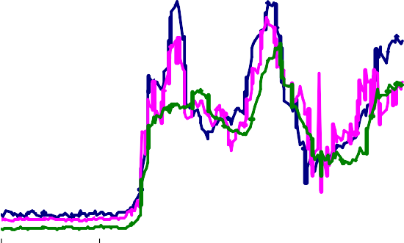

Basis points

120

100

80

60

40

20

0

Apr Jul Oct Jan Apr

2007 2008

Chart 2: Credit Conditions Survey for households: secured credit availability

Perceptions over past three months Expectations over next three months

More credit availabile

Less credit availabile

Net percentage

balance

40



30

20

10

0

-10

-20

-30

-40

-50

2007 Q2 Q3 Q4 2008 Q1 Q2

Chart 3: Credit Conditions Survey for businesses: overall credit availability

Net percentage

Perceptions over past three months Expectations over next three months



More credit availabile

Less credit availabile

2007 Q2 Q3 Q4 2008 Q1 Q2

balance

40

30

20

10

0

-10

-20

-30

-40

-50

-60

Chart 4: Number of mortgage products offered

Thousands

10

Prime products

Credit-impaired products

8

6

4

2

0

FebMar Apr May Jun Jul Aug Sep Oct Nov Dec Jan Feb Mar

2007

Source: Moneyfacts.

2008

Chart 5: House prices and consumer spending

40 12

Percentage changes on

a year earlier

Percentage changes on a year earlier

Real house prices (left-hand scale)

Real consumer spending

(right-hand scale)

30 10

8

20

6

10 4

0 2

0

-10

-2

-20 -4

-30 -6

1966 1971 1976 1981 1986 1991 1996 2001 2006

Chart 6: Retail sales volumes

Percentage changes

8

3 months on previous year

3 months on previous 3 months

7

6

5

4

3

2

1

0

-1

-2

2003 2004 2005 2006 2007 2008

Chart 7: Investment intentions(a)

Differences from averages since 2000 (numbers of standard deviations)

3

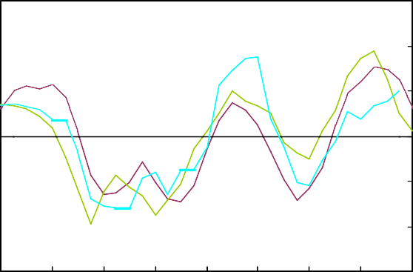

BCC

Agents

CBI

2

1

0

-1

-2

-3

2000 2001 2002 2003 2004 2005 2006 2007 2008

1. Measures weight together sectoral surveys using shares in real business investment. CBI and BCC survey data are four-quarter moving averages. Agents figure for Q1 based on data to February.

Chart 8: Sterling effective exchange rate

Index : Jan 2005 = 100

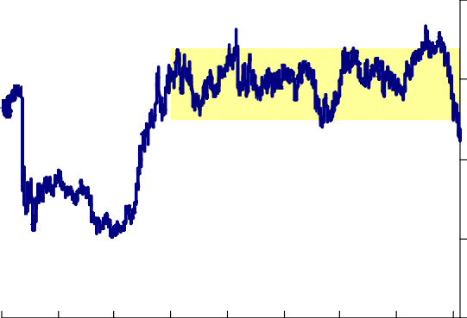110

100

90

80

70

1992 1994 1996 1998 2000 2002 2004 2006 2008

Chart 9: Brent crude oil price

S per barrel

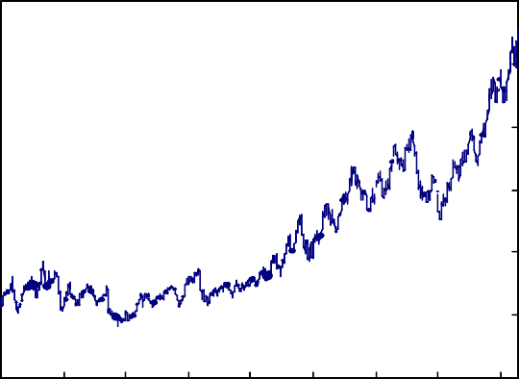120

100

80

60

40

20

0

2000 2001 2002 2003 2004 2005 2006 2007 2008

Chart 10: Contributions to consumer price inflation(a)

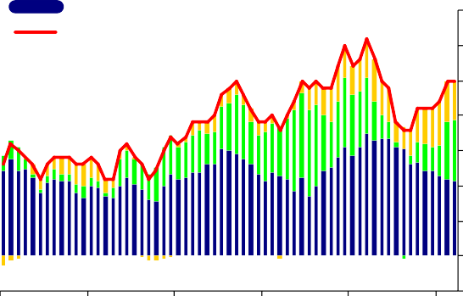Food Energy Other

CPI inflation (per cent)

Percentage

points

3.5

3.0

2.5

2.0

1.5

1.0

0.5

0.0

-0.5

2003 2004 2005 2006 2007 2008

* 1. ‘Food’ defined as food and non-alcoholic beverages; ‘energy’ defined as petrol, electricity, gas and other fuels.

Chart 11: Private sector regular pay

Percentage changes on a year earlier

6

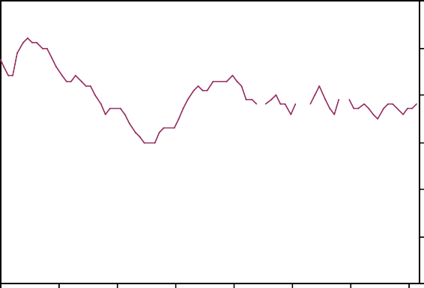

5

4

3

2

1

0

2001 2002 2003 2004 2005 2006 2007 2008

Chart 12: Contributions to consumer price inflation(a)

Percentage points

1.5

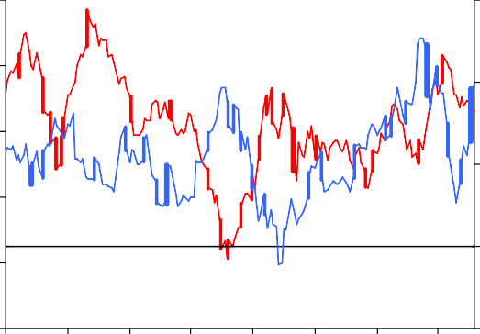

Non-energy (right-hand scale)

Energy

(left-hand scale)

Percentage

points 3

1.0

2

0.5

1

0.0

0

-0.5

-1.0 -1

1993 1995 1997 1999 2001 2003 2005 2007

(a) Bank calculations. Contributions estimated prior to 1997. ‘Energy’ defined as petrol, electricity, gas and other fuels.

Chart 13: Survey measures of household inflation expectations

Per cent

4.0



Citigroup 5-10 years ahead

Bank/NOP

1-year ahead

Citigroup 1-year ahead

3.5

3.0

2.5

2.0

1.5

1.0

2004 2005 2006 2007 2008

Sources: Bank of England, Citigroup, Gfk NOP, YouGov.

Chart 14: February 2008 *Inflation Report* projection for GDP growth based on market interest rates

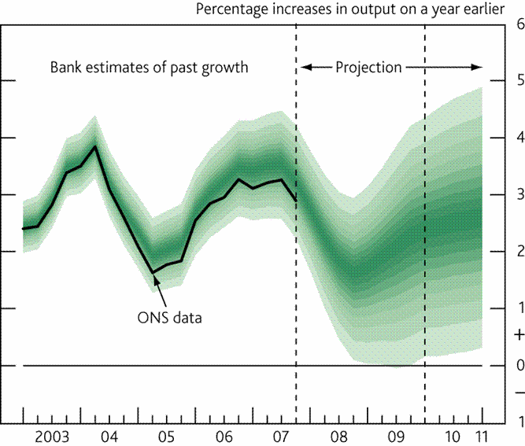

Chart 15: February 2008 *Inflation Report* projection for CPI inflation based on market interest rates

